|  |
| --- |
|  |
|  |
| |  |  |  |  |  | | --- | --- | --- | --- | --- | | MMF2025 – Risk Management Lab  Pantelis Isaiah – 995354593  Sergio Ortiz Orendain - 1002248533  José Saad Canales - 999048392  Ryan Shrott - 998931223 | |  | | --- | |  | |  | |  | | |
| |  |  |  | | --- | --- | --- | | July 2016 | Risk | **Report** | |

Table of Contents

Portfolio decompositions 2

By asset class and by currency 3

Sensitivities 4

Portfolio Sensitivities 4

Value-at-Risk calculations 4

Credit VaR 6

Credit and Debt Value Adjustments (CVA and DVA) 6

Stressed VaR (SVaR) 7

Stress scenarios 7

Capital Requirements 8

Model Risk 10

Conclusion and Recommendations 10

# Portfolio decompositions

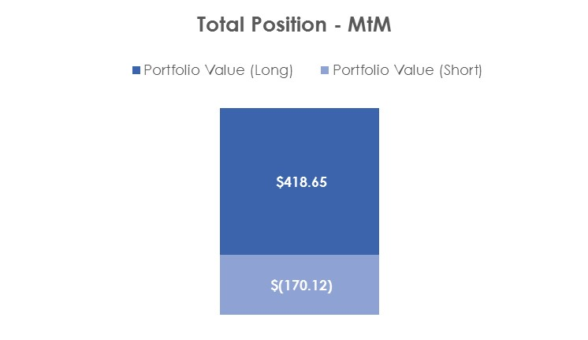

## By sector

The portfolio consists of 32 Bonds, 11 government bonds and 21 corporates. Out of the Bonds, 7 have either expired or been called, which leaves the total composition of the portfolio to 25 bonds. The portfolio also consists of 3 US Stocks, 2 of them listed in the NYSE and 1 in NASDAQ, 2 European Options, 1 American Option; both on US Stocks. Finally, there are 10 Credit Default Swaps (CDS) in the portfolio out of which 1 has expired. These instruments add up to a total value of 248.5M(CAD) dollars. There are several sectors represented in the portfolio, the following table represents the total exposure of our portfolio by sector:

It can be noted that there is a large concentration to 2 sectors, Communications and Government, however we have enough sectors to potentially rebalance the portfolio in order for it to be more diversified sector-wise.

# By asset class and by currency

In terms of asset classes, the portfolio is mainly concentrated in Fixed Income instruments, while Equities (Stocks and Options) represent around 5% of the portfolio. We are exposed to 3 different currencies: Euro, Canadian Dollar and US Dollar. All of the Equity instruments of the portfolio are in US Dollars as well as the CDS contracts. The Bond portfolio consists of 9 USD Bonds, 1 Euro Bond and 15 Canadian Bonds.

It is important to note that almost all of the Bonds in the portfolio are Investment Grades, however there are 2 Corporate Bonds with BB S&P-rating.

# Sensitivities

Market risk takes into account the losses that surge from fluctuation in the market value of our positions due to changes in interest rates, credit spreads, foreign exchange rates and values of equities. The portfolio is exposed to changes in interest rates curves through our position in fixed income (Bonds and CDS). Additionally, there’s exposure to 3 different currencies (USD, CAD and Euro) so we will assume we are an investor that manages its assets and liabilities in Canadian Dollars. Therefore, we are exposed to fluctuations in the value of our portfolio due to changes in the USDCAD and/or EURCAD FX rate. Finally, we are exposed to credit spreads through our corporate bond positions and also through our CDS holdings. The measures we will use for market risk will be portfolio sensitivities (such as DV01, CR01, Duration and Convexity), VaR, Stressed VaR and Stress Scenarios.

# Portfolio Sensitivities

It is important to include the dollar sensitivities of the positions in the portfolio to changes in the underlying interest rate and credit spread.

DV01: It is the dollar value of one basis point that captures the change in value of the portfolio due to a downward parallel shift of 1bp in the yield to maturity (YTM).

CR01: It is the credit risk of one basis point that captures the change in value of the portfolio due to a downward parallel shift of the credit spread.

Since our portfolio has an overall long position in bonds, we can except to benefit from a decrease in interest rate. As for our position in CDS, the portfolio has a negative impact in case of a decrease in the credit spread.

|  |  |
| --- | --- |
| **Sensitivities** | |
| Duration (Long Position) | 12.43 |
| Duration (Short Position) | 4.38 |
| Convexity (Long Position) | 1.54 |
| Convexity (Short Position) | 0.57 |
| DV01 | $210,300 |
| CR01 | $-17,100 |

# Value-at-Risk calculations

## Value at Risk (VaR) and Conditional Value at Risk (CVaR)

Under Basel II.5, Regulatory Value-at-Risk (VaR) is the estimate of the potential decline in the value of a position/portfolio under normal market conditions. We will consider a 10-day horizon VaR at the 99th percentile for all our estimations, however in the table below we present values for different confidence level and time horizons. Our model incorporates the volatilities and correlations of 150 market factors. For the calculation of VaR we consider a time horizon that goes from December 31, 2013 to June 30, 2016. We will use 2 methods for estimating VaR: Monte Carlo and Historical. Our calculations also include the Expected Shortfall (or CVaR), which gives more information about the tail of our Profit and Losses distribution by calculating the average of the losses that exceed VaR. The following table illustrates the values obtained for these statistical measures:

|  |  |
| --- | --- |
|  |  |

From our results we can see that the Historical VaR is higher than the VaR calculated using Monte Carlo. We must take into account that the analytical VAR is more model dependent. To map the portfolio P&L to linear risk factors we work with the DV01 and CR01 (for bonds and CDS respectively). The mapping probably won’t be a good approximation for large movements. That’s why the historical VAR number would be a better representation of our PNL distribution.

|  |  |  |  |  |  |  |  |  |
| --- | --- | --- | --- | --- | --- | --- | --- | --- |
| Time Horizon | VaR - 95% | | VaR - 99% | | US S&P IG Index | S&P 500 | ES – 95% | ES – 99% |
| 1-day | $2.68M | 1.09% | $3.79M | 1.54% | 0.59% | 2.28% | $3.35M (1.36%) | $4.33M (1.76%) |
| 10-day | $8.48M | 3.45% | $12M | 4.88% | 1.88% | 7.20% |  |  |
| 1-year | $54.45M | 22.14% | $78.39M | 31.87% | 9.42% | 36.14% |  |  |

Table2. Historical VaR

Table1. Monte Carlo VaR

|  |  |  |  |  |  |  |  |  |
| --- | --- | --- | --- | --- | --- | --- | --- | --- |
| Time Horizon | VaR - 95% | | VaR - 99% | | US S&P IG Index | S&P 500 | ES – 95% | ES – 99% |
| 1-day | $2.97M | 1.19% | $4.57M | 1.84% | 0.59% | 2.28% | $5.40M (2.17%) | $11.33M (4.56%) |
| 10-day | $9.38M | 3.77% | $14.46M | 5.82% | 1.88% | 7.20% |  |  |
| 1-year | $47.08M | 18.94% | $72.61M | 29.22% | 9.42% | 36.14% |  |  |

## Marginal Value at Risk (MVaR)

When calculating VaR it is always important to report the Marginal Value at Risk so that it is possible to have an idea of what the contribution of each asset class is to the total Value-at-Risk. Marginal VaR allows to study the effects of adding or subtracting positions from an investment portfolio, since our portfolio is greatly exposed to Bonds, we will expect the MVaR for this asset class is higher than all the others.

|  |  |  |
| --- | --- | --- |
| **1-day 99% MVaR** | | |
| **Asset Class** | VaR | % AUM |
| Bonds | 3.87M | 1.58% |
| CDS | -0.015M | -0.01% |
| Options | 0.01M | 0.005% |
| Stocks | 0.05M | 0.02% |

## Incremental Value at Risk (IVaR)

Incremental VaR represents the amount of risk added or subtracted when adding the asset class to our portfolio. If the IVaR of a position is positive then increasing the size of the position slightly will increase the value at risk of the portfolio. Likewise, if the IVaR is negative then increasing the size of the position slightly will lower the value at risk of the portfolio. What we can see from the following table is that Bonds add the most risk to our portfolio. This could be due to the great exposure we have to these instruments

|  |  |  |  |  |  |  |  |  |  |  |  |  |  |  |  |  |  |  |  |  |  |  |  |  |  |  |  |  |  |  |  |  |  |  |  |  |  |
| --- | --- | --- | --- | --- | --- | --- | --- | --- | --- | --- | --- | --- | --- | --- | --- | --- | --- | --- | --- | --- | --- | --- | --- | --- | --- | --- | --- | --- | --- | --- | --- | --- | --- | --- | --- | --- | --- |
| |  |  |  | | --- | --- | --- | | **1-day 99% IVaR** | | | | **Asset Class** | VaR | % AUM | | Bonds | 3.46M | 1.39% | | CDS | 0.46M | 0.19% | | Options | 0.54M | 0.22% | | Stocks | 0.68M | 0.27% | | |  |  |  | | --- | --- | --- | | **1-day 99% IVaR** | | | | **Asset Class** | VaR | % AUM | | Bonds | 4.06M | 1.63% | | CDS | -0.33M | -0.13% | | Options | -0.32M | -0.13% | | Stocks | -0.26M | -0.10% | |

Table4. Historical

Table3. Monte Carlo

# Credit VaR

To calculate the Credit Risk of our portfolio, we used the CreditMetrics approach. This measure is of high importance since 90% of our portfolio is exposed to credit instruments. To calculate this value we used the transition matrix from the S&P 2015 Credit Report.

|  |  |  |
| --- | --- | --- |
| **Credit VaR** | | |
| Confidence Level | **VaR** | **% AUM** |
| 99.9% | 52.49M | 21.12% |

# Credit and Debt Value Adjustments (CVA and DVA)

|  |  |
| --- | --- |
| **CVA** | **DVA** |
| 114840 | 257374 |

# Stressed VaR (SVaR)

The methodology for the SVaR is the same as for the Regulatory VaR methodology (99% confidence level and 10 day holding period) with the exception of the look back period. For the SVaR we calibrate the model to historical data using a continuous 24-month period that reflects significant financial stress. The period considered was the 2007-2009 financial crisis aftermath. We can see that the SVaR is $17.39 MM, which exceeds the VaR calculated using Monte Carlo and historical methods. Therefore, it is important to take into account SVaR which gives a better insight of the portfolio potential decline during stressed periods.

When computing the stressed Value-at-Risk it was found that the most stressed 504-day window occurred from 03/07/07 through 03/07/09. The reported stressed value at risk during this period was

|  |  |  |
| --- | --- | --- |
| **Stressed VaR** | **Market Value** | **% AUM** |
| Daily | 5.5M | 2.21% |
| Ten Day | 17.4M | 7.00% |

# Stress scenarios

To complement our VaR and SVaR results we will compute the value of the portfolio under determined historical scenarios/crisis under the historical scenario approach. This will help us estimate the impact of our portfolio to extreme market movements and evaluate the potential effects of tail events on our portfolio and consider periods where the portfolio had make significant losses due to the market conditions.

We chose 4 historical scenarios and one hypothetical; the losses of these scenarios are represented in the following figure.

x 107

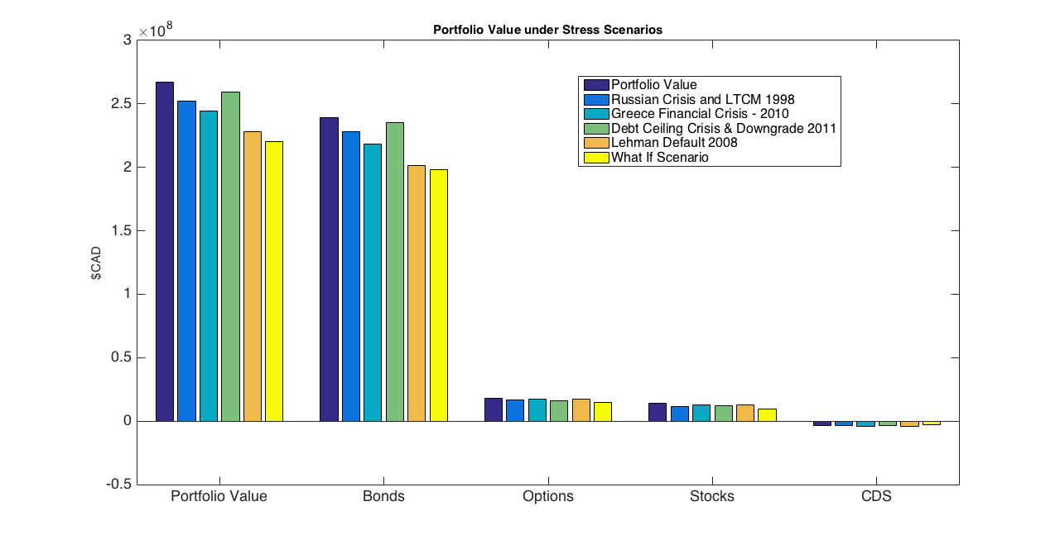

Given that the composition of our portfolio consists mainly of bonds, the Credit Crisis of 2008 shows the worst historical loss; this gives an idea of the exposure to credit and fixed income instruments. The hypothetical scenario shows a severe loss in our Bond Portfolio, however we can see that all the other asset classes have a substantial loss.

# Capital Requirements

## Market Risk

On Basel Regulatory Capital there are two principal components required to obtain the capital requirements: one market component and one credit risk component.

Based on the Basel II.5 document, the following formula needs to be used to calculate our market risk regulatory capital:

$$K=\max\left(VaR_{10d 99\%};mc VaR_{avr 10d 99\%}\right)+max⁡(SVaR_{10d 99\%};mc SVaR_{avr 10d 99\%})$$

The following table represents the total Regulatory Market Capital:

|  |  |
| --- | --- |
| **Market Regulatory Capital** | |
| Market Value | % AUM |
| 98.6M | 39.7% |

## Incremental Risk Charge (IRC)

The incremental risk charge (IRC) complements the VaR framework by projecting the effects of credit rating migration into VaR. In IRB, only the default events are considered in the credit risk capital. The IRC metric is a more robust measure since downgrades are also considered in the credit risk modelling. To consider the migration we will use a Transition Matrix obtained from S&P.

CreditMetrics methodology as well as Gaussian copulas are used to model the rating transitions. The details of the methodology can be found in our documentation. The one-year 99.9% VaR is calculated using 2000 MC simulations.

|  |  |
| --- | --- |
| **IRC VaR - 99.9% 1y** | |
| Market Value | % AUM |
| 55.7M | 22.4% |

Adding both the market and the credit factors, we obtain a total capital requirement of 154.3M; which represents 62.1% of the total value of the portfolio.

## Economic Capital

The Economic Capital is the Capital designated to cover unexpected Market losses. The Economic Capital provides a forward-looking estimate of the difference in the maximum potential loss and our expected losses:

$$K_{economic}=VaR_{10d99\%}-Expected Loss$$

The total value of the Economic Capital adds up to 13.6M; which represent 5.5% of the portfolio value.

## Standardized Approach for CCR

The capital allocation is based on the following formula proposed in Basel I, where the weights and credit equivalent add-on factors are:

$$K=0.08 (Σ_{j}RWA_{j})$$

This adds up to 0.27M, which represent 3.1% of the total exposure to CDS.

## Standardized CVA Capital

In the standardized approach, the portfolio CVA capital charge is calculated using the following formula:

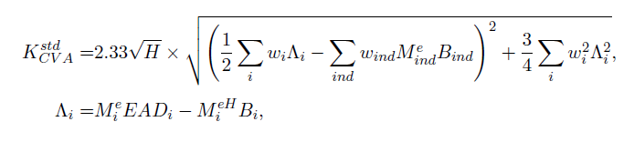

The capital we obtain for the CVA is the following: $K=0.22M$, representing 2.6% of the Total CDS Exposure.

# Model Risk

Model risk is the possible losses due to faults in the development and application of the valuation models considered.

**Interpolation of Zero Curves and Spread Curves:** For our pricing models we had to interpolate the interest rate curves as well as the CDS spread curves. Given that we only have an observation for determined tenors, an interpolation has to be done to obtain a curve. This position mapping was done with a linear approach, although several other methods exist. A disadvantage of the linear interpolation is that it can either underestimate or overestimate volatility of the cash flows being discounted.

**Agency Rating Risk:** For credit risk we use the agency ratings for valuing our portfolio. It has been proven that these ratings might not be correct and may overestimate the value of the financial instrument. Another problematic issue that arises is that the bonds with the same rating do not necessarily have the same spread.

**Liquidity:** Within our models we are not considering the liquidity risk of the instruments. We are valuing the instruments without pricing in a liquidity factor. This then might implicate an overestimation or underestimation of the instruments prices.

**Jointly Normal Assumption:** We assumed that the risk factors are jointly normal in the calculation of the analytical VaR. This is also the case in model risk. As we know Normality assumption is not a realistic assumption. A better approach would have been using a distribution with skewness and kurtosis for calculation of analytical VaR.

**Gaussian Copula:** Gaussian copulas generally cannot capture the tail dependence very well, however it is known that T-copulas are a good candidate for capturing the tail dependence. It is expected by switching to t-copulas, the VaR value calculated by the IRC approach increases which provide a better (more realistic) estimate for worst case capital loss and capital allocation.

**Double default:** In our CCR model we have not considered the existence of correlation between the counterparty and the reference entity in the CDSs. In practice in the extreme market conditions default correlation becomes high which impacts the default risk capital allocation. The double default has been considered in the Basel III framework but it has not been included in our models.

# Conclusion and Recommendations

In this report, we analyze the risk associated with a portfolio consisting of different asset classes: corporate bonds, options, stocks and CDS. Market risk and credit risk were also considered for this purpose.

As for recommendations, we know that we are over-exposed to the communications sector and the government issues. We recommend reducing the exposure in these areas. We suggest to homogenize the risk contributions by sector, instead of having these huge exposures in some of them, and so little in others. In addition, the USD exposure is 2/3 of the total portfolio value. This means that we could invest more in other currencies, instead of that huge risk factor.

Moreover, the duration of the portfolio is 8.0 years. We recommend to decrease this number, between 4-9 years. Because, this number implies that we need to reevaluate the portfolio frequently to determine if its allocations and exposures have changed. Doing this can help us indicate whether a weighted cash flow frequency over this horizon is expected or not. As the bonds begin to mature or default, the portfolio weightings change, altering its behavior and performance. It is also important to monitor exposures to key risk factors, and determine whether the portfolio is behaving as expected.

We could measure our portfolio risk better, we suggest a 60% equity exposure and 40% bonds. These would give us a benchmark to measure our risks more correctly. It will also let us compare against multiple benchmarks in the market.

For the construction of our models, in particular market risk, VaR and CVaR were calculated for normal and stressed markets. We used two different methods for the VaR calculation: Monte Carlo simulation and historical. We found out that the VaR for stressed market is significantly higher than VaR for Normal market. The time horizon considered was ten days. In addition, the historic VaR is much higher than the Monte Carlo VaR, which helps us be more conservative about this risk measure.

VaR and stress testing are estimates of portfolio risk, but have limitations. Among the limitations of VaR is the assumption that all positions can be liquidated within the assigned holding period which may not be the case in an illiquid market condition. Additionally, the historical data can be used as a proxy to predict future market events. Neither VaR nor stress testing is viewed as a definitive predictor of the maximum amount of losses that could occur because both measures are computed at prescribed confidence levels and their results could be exceeded in highly volatile market conditions.

Credit VaR was also modeled supposing the probabilities of default with the S&P transition matrix and the Gaussian Copula model. We have to imply that there exists some big assumptions in this model since we are considering actual cases (empirical probabilities), and not the real probability of default. The CreditMetrics approach was used to find the one-year VaR. A more involved approach may produce slightly more accurate results, but the added precision may not be worth the time required to implement it. It may also add unreasonable model assumptions.